What is R?

Why would I use it?

[R programming for beginners - Why you should use R](https://www.youtube.com/watch?v=9kYUGMg_14s)

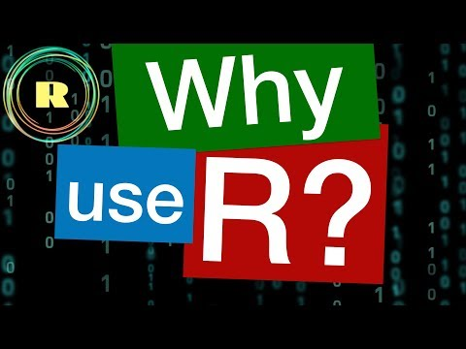

How do I install it at the EPA?